***Policies & Procedures***

**ATTENDANCE**

In the event of an absence please contact me, this also applies if you are running behind. All work is expected to be made up in the event of your absence. You can only miss 2 classes upon missing the 3rd class your enrollment will be terminated. Please if you have scheduling conflicts let me know, and we will work around the conflict.

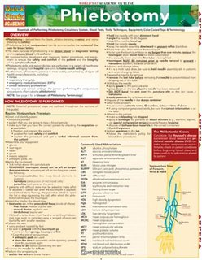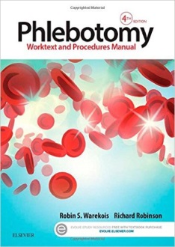**TEXTBOOKS**

We will use the **Phlebotomy: Worktext and Procedures Manual, 4th Edition**, by Robin S. Warkois BS MT (ASCP) and Richard Robins. It can be purchased ($60-70) or rented ($25-30) at Amazon.com Or Barnes and Noble

I would also recommend purchasing **Phlebotomy (Quickstudy: Academic) Pamphlet, b**y Inc. BarCharts. It can be purchased ($6.25) at Amazon.com.

**COURSE COST**

The cost of the program is $700.00, this covers the supplies for the course, including malpractice insurance, ID badge, and the National Healthcare Association exam fee, as well as all associated study material I will accept payment in installments, however I will need $100.00 the first night of classes and the full amount must be paid in FULL with a minimum payment of $50 each week or $100 every other week. IF you plan to make payments I will need a copy of your credit card or voided check to retrieve remaining balances if not paid in full. We do accept credit cards $7.50 for each transaction **THERE ARE NO REFUNDS.**

**VACCINE REQUIREMENTS**

You are required to be up to date on ALL vaccinations. You are also required to have a TB screening, MMR Vaccine, Hepatitis B Vaccine, and seasonal Flu Shot which can be performed at your local health department. You are required to have this screening and provide me with a copy of the results before you begin clinicals.

**DRUG TESTING**

Drug Tests will be performed on site at the training center, failing to take, and pass the random drug test is grounds for termination; an informal meeting will be healed to discuss your future in the program.

**SMOKEING/TABACCO USE**

Our facility is smoke free/ tabacco free no smoking or tabacco use permitted inside the classroom or during breaks, unless in your automobile.

**DESSCODE**

Scrubs will be expected to be worn to class by October 3, 2018

**BACKGROUND CHECKS**

Background checks will be performed by the Missouri Department of Health and Senior Services, Family Care Safety Registry.

**CLINICALS**

* All clinicals will be performed at Mercy-Lincoln in Troy. Please call, be flexible and be patient with scheduling clinical rotations. IF the distance is a concern we can try to establish a clinical site closer to you, We do have existing contracts with Hannibal Reginal, and Pike County Hospital; at times these clinical sites cannot accept students.
* YOU are required to schedule your own clinicals. I will help with scheduling if needed.
* You have 3 months to complete ALL CLINICALS.
* SCRUBS AND I.D. BADGE **MUST BE WORN**. If you do not have on proper identification or the proper attire YOU will be sent home.
* Please remember to behave in a professional manner. Remember to bring your lunch with you especially on the weekends.
* **EIGHTY (80)** clinical hours will be performed in the Laboratory.
* **FIFTY (50)** successful blood draws must be performed and documented.

HPSO**MALPRACTICE INSURANCE**

You are covered to perform clinicals our malpractice insurance company is Healthcare Providers Service Organization.

**LIABILITY WAIVER**

You will be required to sign a waiver of liability, as will any person that you bring as volunteer for skills days.